ResourceFinder(Managing Medical Data Team)
Date : 24th October 2004
Scenarios (Short Stories)
Note : We are assuming fictitious names to make story interesting. The screenshots provided are just preliminary ideas.

- Scenario: Ms. Sheryl searches for ‘Gene therapy for carcinoma of the breast’ by using simple search.

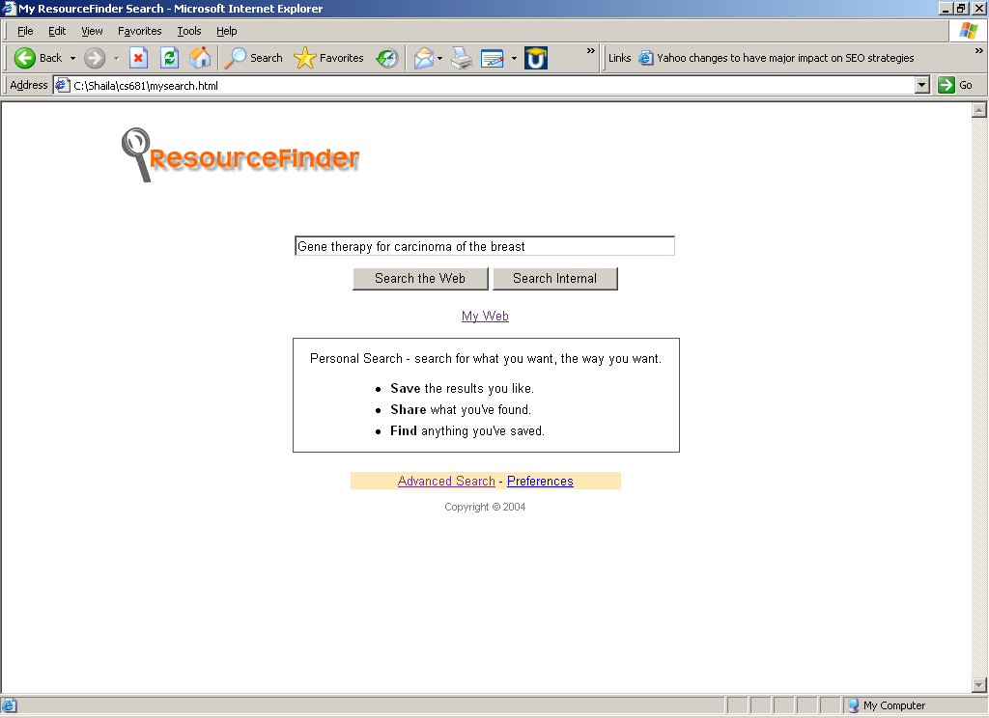
Ms. Sheryl remembered that Dr. Andrew William asked her to look for some information on gene therapy for carcinoma of the breast. She is happy to have the right tool to find out information on this topic, ResourceFinder. She opens the application/browser and types in text in the keyword box ‘Gene therapy on carcinoma of the breast’ and hits the ‘Search’ button. The application opens another window displaying all the search results from local and network drives as well as from the web. She skims through the list of the results, which are displayed by relevance. She goes through all the files found in the local C drive and some links from ‘PubMed’. One of the articles from ‘PubMed’ is more close to the information she is looking for. She decides to print the same. She tries to get more results by again putting more relevant words and after number of iteration, Sheryl has couple of pages of information, which she thinks Dr. Andrew will be pleased to see. She decides to quit the application.

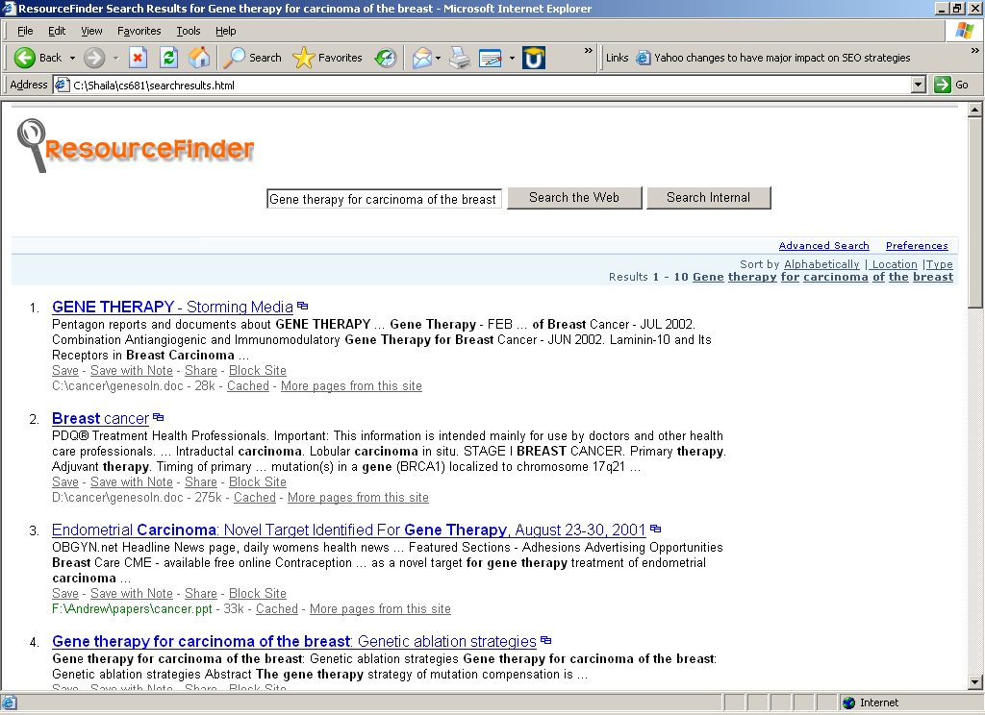
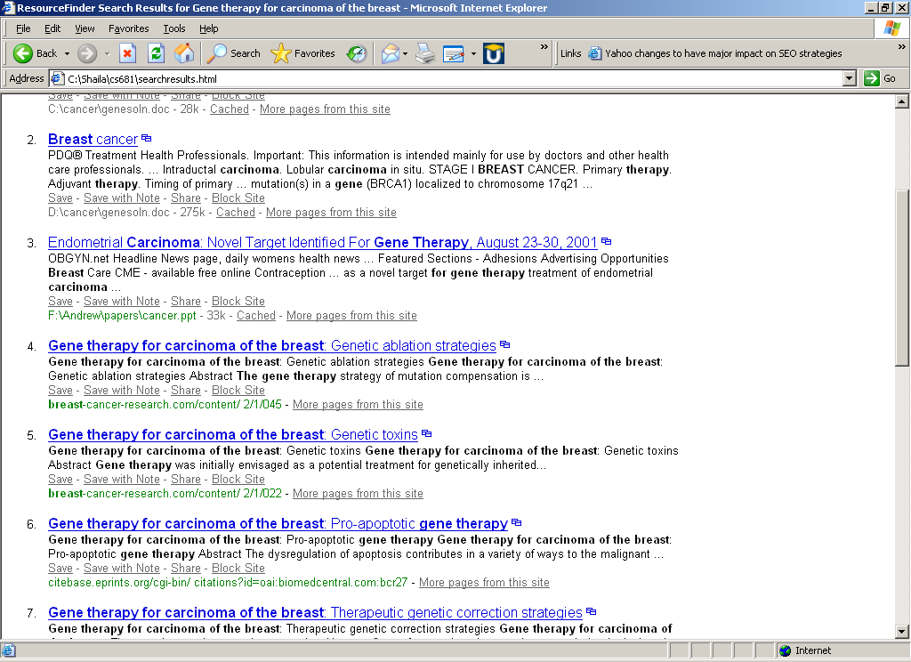

- Scenario: Ms. Sheryl searches for ‘Gene therapy for carcinoma of the breast’ by using advanced search.

Ms. Sheryl remembered Dr. Andrew William was looking for some information on gene therapy for carcinoma of the breast. She is happy to have the right tool to find out information on this topic, ResourceFinder. She opens the application and types in text in the keyword box ‘Gene therapy on carcinoma of the breast’. She remembered that she has some related documents saved in the local c drive on her desktop and some articles on this topic she read on the ‘PubMed’. So she hits the ‘Advanced search’ button. The application displays her several options, Google, PubMed, Yahoo , local c drive, local d drive, etc and boxes to include and exclude certain words. She decides to select only local c drive and PubMed and hits the ‘Search’ button. The application opens another window, which displays all the search results. She goes through all the files found in the local C drive and some links from ‘PubMed’. She finds out a particular article listed in the results, which is from ‘PubMed’ and decides to get the print out of the same. It provides her sufficient information so she decides to quit the application.

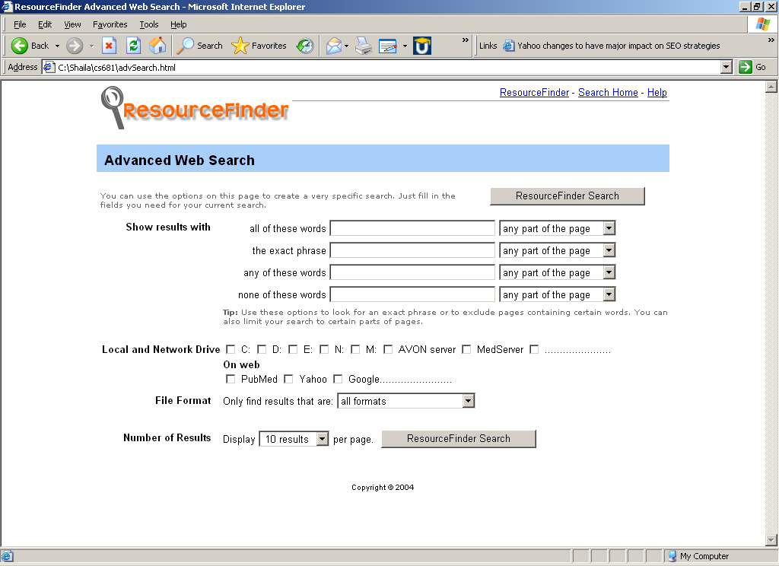

- Scenario: Sorting the search results
Ms. Sheryl has search results on ResourceFinder application window. She decides to sort these results by one of predefined search categories such as by alphabetical order or by file type or by search location. She chooses one of the available sorting options on the screen i.e. by location. ResourceFinder then displays the sorted results by the selected criteria.

- Scenario: Save the results for future reference
Dr. Andrew was pleased to see the search done by Ms. Sheryl. After few days Dr. Andrew needs to go through the information he had before. But he doesn’t remember where he kept those printed documents. He asks Sheryl if she has those results saved/stored somewhere. Sheryl didn’t save the results last time. She does search one more time but this time she decides to save these results. ResourceFinder displays a small link/button under every result, which allows her to save the link. She also wants add some user-friendly note to what she is saving. ResourceFinder displays her a small box to add the note to the result. Sheryl adds a note. So now the result is saved with little annotation for the future use.

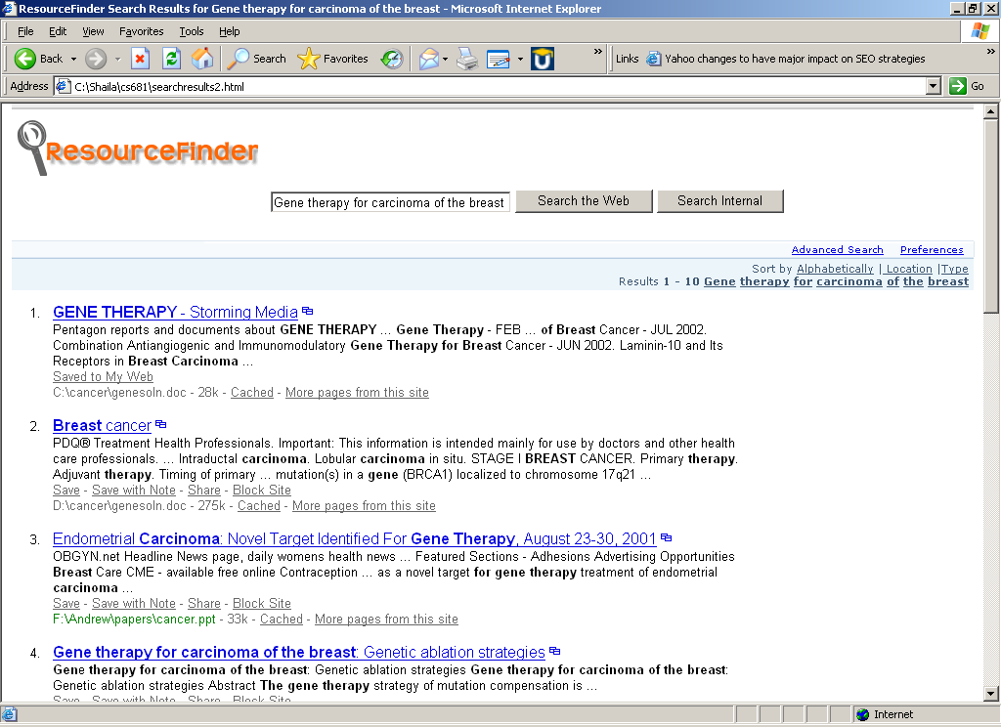
- Scenario: Retrieve and Edit the earlier saved results
Ms. Sheryl did some search for Dr. Andrew few days ago. She saved those search results. Today she wants to delete, update few entries, which were not much relevant and outdated. She has ResourceFinder application handy. She opens ResourceFinder application. She opens my saved search, which looks like as follows:

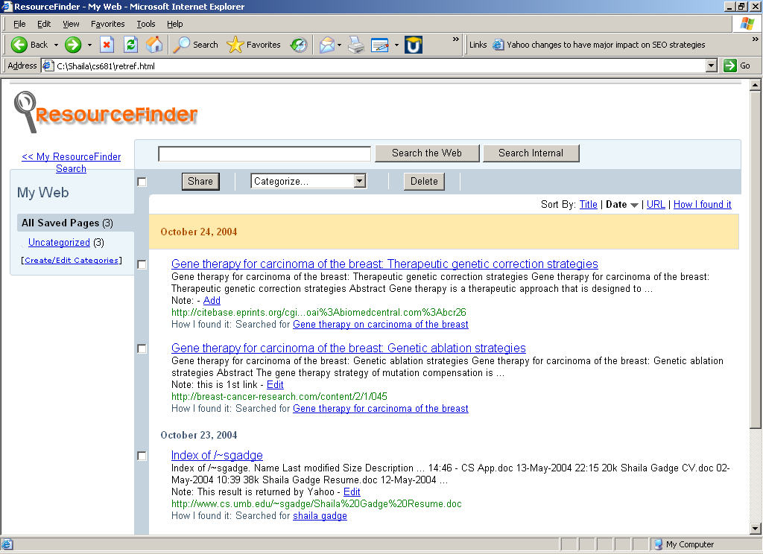

Sheryl deletes unwanted search by selecting unwanted entries and hits delete button. On next screen she sees that she can categorize some of her searches she can do so by choosing the entry and categorize option as shown.

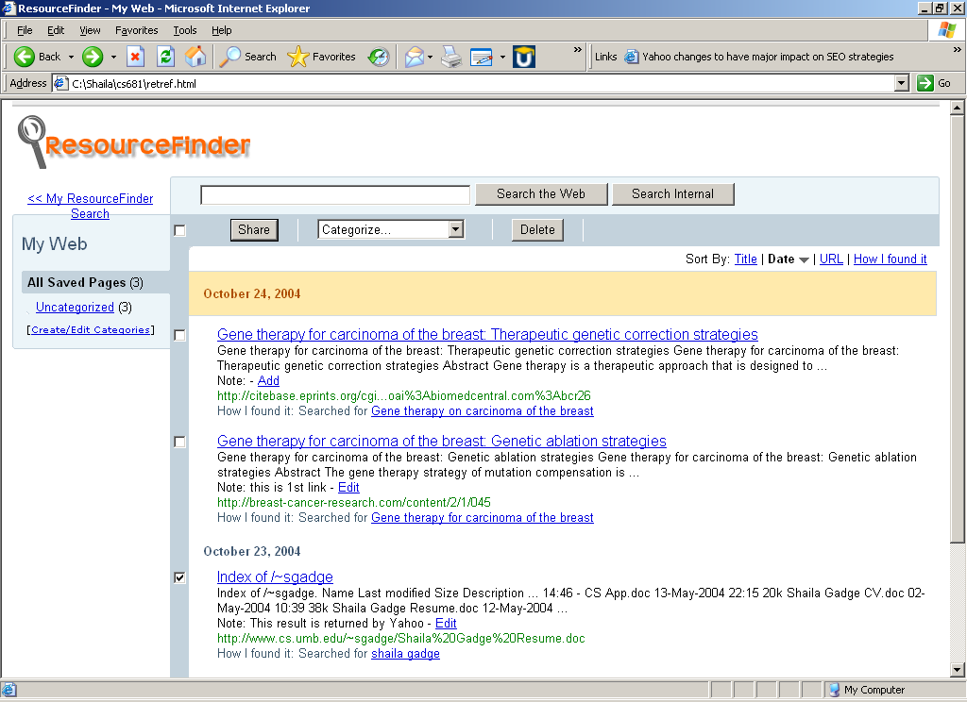

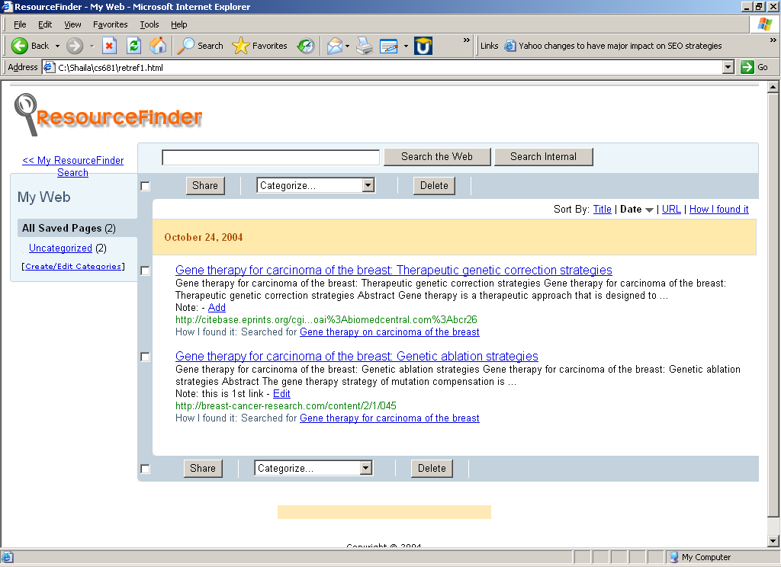

Acknowledgments:
Thanks to Prof. Ethan Bolker for helping us out understanding the use case scenarios. Visual ideas are taken from mysearch.yahoo.com.

